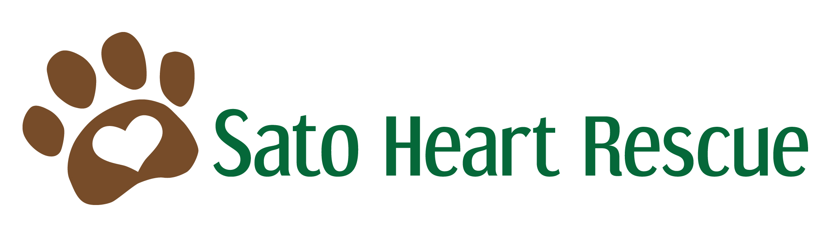
ADOPTION APPLICATION
Name(s):

Address:

City: | State: | Zip:
Home Phone:  Best time to Call: | Cell Phone:
Work Phone:
Best time to Call:
Email Address:

Occupation(s):
Employer(s):
Veterinarian:

Veterinarian’s Phone:
Please contact your veterinarian(s) to give permission for them to discuss your care. Many offices require consent from the owner to release information. If you have used multiple Veterinarians, please list them all.

Please tell us why your family is looking to add a dog to your home:

Please tell us about your preferences and what type of dog is best suited for your home:

Age:
Size:
Gender:
Temperament:
Activity Level:
If you have a specific dog in mind please name him/her here:

Do you live in: ___House ___Condo ___Apartment ___Other Do you: ___ Own ___Rent
If you rent, please provide your landlord’s phone #:
If you live in a condo, please provide management office phone #:
How long have you lived here?
Are you planning to move within the next year? ___Yes ___No
How many adults live in your home?
Please list how many children live in your home and their ages:
Who will be doing the majority of the daily care for the dog?
Who will be responsible for the training of the dog?
Who will be responsible for providing the dog with adequate exercise, and in what way?

Please list all pets currently in the household:
(Name/Species/Breed/Age/Sex)

Please list and describe any previous pets you have owned:
(Name/Species Breed/Years of Ownership/Reason for Death or Removal)

Have you ever adopted from a shelter or rescue before? ___Yes ___No
If yes, name and phone number:
What is your family’s dog training experience? Are you familiar with crate-training and/or positive reinforcement training?
Please list what you know regarding the yearly and monthly veterinary care a dog needs. Have you budgeted sufficiently for this care?
How many hours will your dog be alone each day?
Please explain your set-up and philosophy for your dogs while you are not home:
Where will the dog sleep?
Please describe your yard and outside dog accommodations:

How did you hear about us? __Petfinder.com ___Flyer ___Word of Mouth ___Other
Please provide additional detail if other than Petfinder.com:

Would you like to be notified of upcoming Sato Heart Rescue events (Santa Photos, Halloween Costume Party, etc.)? __Yes ___No

Do you agree to return the dog to Sato Heart Rescue for re-homing if you can no longer keep or care for it? ___Yes ___No

Signature __________________________________________________ Date _____/_____/_____

Thank you for considering one of our deserving dogs! Our adoption approval consists of confirmation of good veterinary care with previous or current animals and a phone interview with our Adoption Director. Our mission at Sato Heart Rescue is to find the best possible situation for our dogs. We do not adopt out on a first come basis, but strive to find the perfect match for the dog and his/her new family. Adopting a dog is a 12 to 16 year commitment. We hope to make it one of the most rewarding experiences of your life!
Completed applications may be emailed to satoheartadoptions@gmail.com and do not require a signature.

